
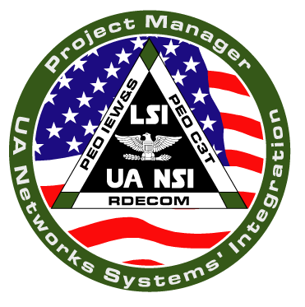
DEPARTMENT OF THE ARMY
Office of the Project Manager
Unit of Action, Networks Systems’ Integration
Albert J. Myer Center, Building 2700
Fort Monmouth, New Jersey 07703-5201

REPLY TO THE
ATTENTION OF

SFAE-GCS-UA-NS 07 June 2004

MEMORANDUM FOR PM UA NSI

SUBJECT: WebEx Collaborative Environment Security and Use Policy

1. References:

a. AR 25-2, Information Assurance, 14 November 2003

b. AR 25-1, Army Information Management, 31 May 2002, effective 28 June 2002.

2. Description: WebEx is an independent, privately owned internet company that provides services allowing companies, organizations and individuals to participate in collaborative sessions via the internet. Documents, Power Point slide, and other information are viewed simultaneously by all participants via computer link using a standard internet browser such as Microsoft Internet Explorer. Participants are provided a meeting number and password by the host, and the first time a session is attended participants will receive a "plug-in" to their browser, which enables them to view the shared documents or slides.

4. Policy:

a. Boeing has entered into a contract with WebEx placing explicit security restrictions on the server at the WebEx facility through which Boeing sessions are conducted. In addition, Boeing has released security guidelines for participation in a WebEx session (attached at encl 1) that parallel's the restrictions of the IATO, some of which is further described cited below.

b. Use of WebEx for the Fort Monmouth community in support of PM UA NSI is restricted solely to those sessions hosted and initiated by the Boeing Company. WebEx may not be use through any other means without prior approval.

c. In addition to the above, the following policies apply:

1) WebEx sessions must be conducted IAW the procedures described by Boeing
(See encl 1), and also in accordance with the risk management process (encl 2).

SFAE-GCS-UA-NS
SUBJECT: WebEx Collaborative Environment Security and Use Policy

2) Browsers must be 128-bit encryption enabled, and the session conducted over port 443 (or "https" - a symbol of a closed padlock will be at the bottom of the browser window).

3) Transmission of the meeting number and password must be via tow separate mediums, such as two e-mails, or on e-mail and one phone call. The meeting number and password must NEVER be provided together.

4) Classified data or information must NEVER be presented in a WebEX session. Maximum level is sensitive (formerly sensitive by unclassified).

5) Only authorized and/or invited attendees should participate in a WebEx session.

6) Documents with OPSEC considerations should not be viewed in a WebEx session. This includes such items as lists of personnel with phone numbers, addresses and other personal information; calendars or schedules of General Officers or other senior officials; status of troops and movements, and so on.

7) Violations of this policy of misuse of WebEx in any wall will be reported immediately to the Information Assurance Manager, CERDEC as well as the PM UA NSI Security Manager.

5. POC for this action is my Security Specialist, Ms. Beverly J. Gibson she can be reached at
732-427-0759

Encls JONATHAN A. MADDUX
as COL, SC
Project Manager, PM UA NSI

2

